Batch: A2 Roll No.: 1610322014
Experiment / assignment / tutorial No. 3
Grade: AA / AB / BB / BC / CC / CD /DD
Signature of the Staff In-charge with date

Title: Implement VLANs and Trunking
Objectives:
Part 1: Build the Network and Configure Basic Device Settings
Part 2: Create VLANs and Assign Switch Ports
Part 3: Configure an 802.1Q Trunk between the Switches
OUTCOME:
CO 1. Understand switched networks and Implement Virtual LAN (VLAN)

Tools required:
- 2 Switches (Cisco 2960 with Cisco IOS Release 15.2(2) lanbasek9 image or comparable)
- 2 PCs (Windows with a terminal emulation program, such as Tera Term)
- Console cables to configure the Cisco IOS devices via the console ports
- Ethernet cables as shown in the topology

Theory:
Modern switches use virtual local-area networks (VLANs) to improve network performance by separating large Layer 2 broadcast domains into smaller ones. VLANs address scalability, security, and network management. In general, VLANs make it easier to design a network to support the goals of an organization. Communication between VLANs requires a device operating at Layer 3 of the OSI model.
VLAN trunks are used to span VLANs across multiple devices. Trunks allow the traffic from multiple VLANs to travel over a single link, while keeping the VLAN identification and segmentation intact.
In this lab, you will create VLANs on both switches in the topology, assign VLANs to switch access ports, verify that VLANs are working as expected and create VLAN trunks between the two switches.


Task:

Topology

Addressing Table

Device | Interface | IP Address | Subnet Mask
S1 | VLAN 10 | 192.168.10.11 | 255.255.255.0
S1 | VLAN 20 | 192.168.20.11 | 255.255.255.0
S1 | VLAN 30 | 192.168.30.11 | 255.255.255.0
S2 | VLAN 10 | 192.168.10.12 | 255.255.255.0
PC-A | NIC | 192.168.20.13 | 255.255.255.0
PC-B | NIC | 192.168.30.13 | 255.255.255.0
VLAN Table

VLAN | Name | Interface Assigned
10 | Management | S1: VLAN 10  S2: VLAN 10
20 | Sales | S1: VLAN 20 and F0/6
30 | Operations | S1: VLAN 30 S2: F0/18
999 | ParkingLot | S1: F0/2-5, F0/7-24, G0/1-2  S2: F0/2-17, F0/19-24, G0/1-2
1000 | Native | N/A

Part 1: Build the Network and Configure Basic Device Settings
In Part 1, you will set up the network topology and configure basic settings on the PC hosts and switches.

Step 1: Cable the network as shown in the topology.

Attach the devices as shown in the topology diagram, and cable as necessary.

Step 2: Configure basic settings for each switch.
- Console into the switch and enable privileged EXEC mode.
- Assign a device name to the switch.
- Disable DNS lookup.
- Assign class as the privileged EXEC encrypted password.
- Assign cisco as the console password and enable login.
- Assign cisco as the VTY password and enable login.
- Encrypt the plaintext passwords.
- Create a banner that warns anyone accessing the device that unauthorized access is prohibited.
- Copy the running configuration to the startup configuration.

Step 3: Configure PC hosts.
Refer to the Addressing Table for PC host address information.
Part 2: Create VLANs and Assign Switch Ports
In Part 2, you will create VLANs as specified in the table above on both switches. You will then assign the VLANs to the appropriate interface. The show vlan brief command is used to verify your configuration settings. Complete the following tasks on each switch.

Step 1: Create VLANs on both switches.
- Create and name the required VLANs on each switch from the table above.
- Configure the management interface on each switch using the IP address information in the Addressing Table.
- Assign all unused ports on the switch to the ParkingLot VLAN, configure them for static access mode, and administratively deactivate them.

Step 2: Assign VLANs to the correct switch interfaces.
- Assign used ports to the appropriate VLAN (specified in the VLAN table above) and configure them for static access mode.
- Verify that the VLANs are assigned to the correct interfaces.

Part 3: Configure an 802.1Q Trunk Between the Switches
In Part 3, you will manually configure interface F0/1 as a trunk.

Step 1: Manually configure trunk interface F0/1.
- Change the switchport mode on interface F0/1 to force trunking. Make sure to do this on both switches.
- Set the native VLAN to 1000 on both switches.
- As another part of trunk configuration, specify that only VLANs 10, 20, 30, and 1000 are allowed to

cross the trunk.
d. Issue the show interfaces trunk command to verify trunking ports, the native VLAN and allowed VLANs across the trunk.

Step 2: Verify connectivity.
Verify connectivity within a VLAN. For example, PC-A should be able to ping S1 VLAN 20 successfully. Were the pings from PC-B to S2 successful? Explain.

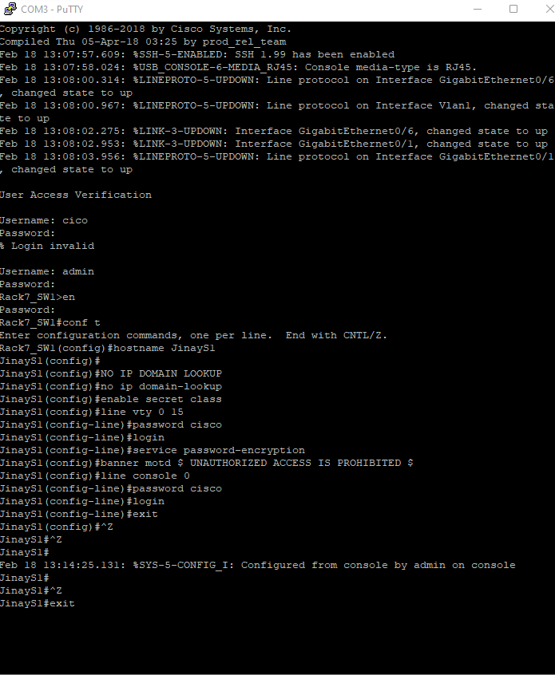

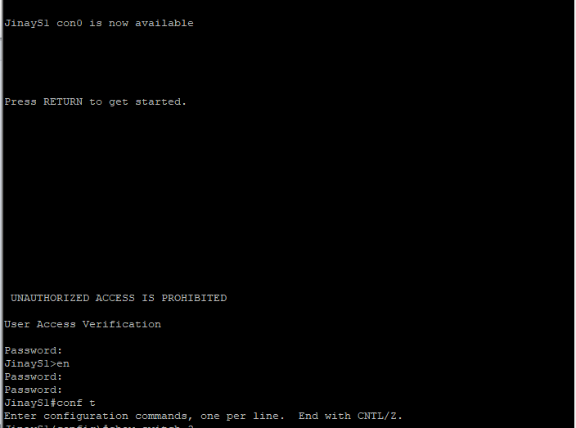

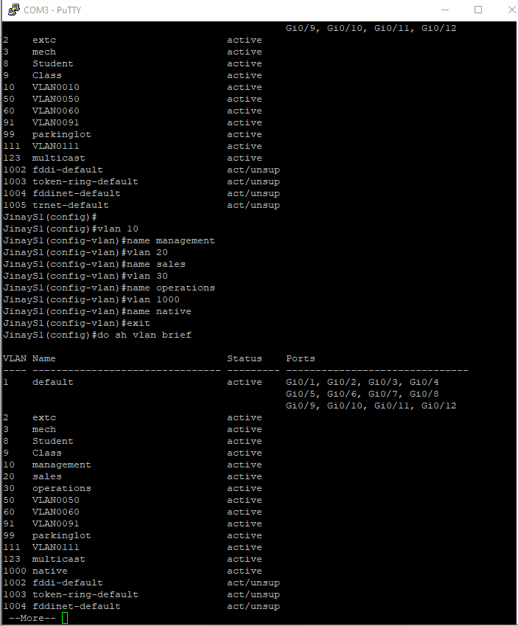

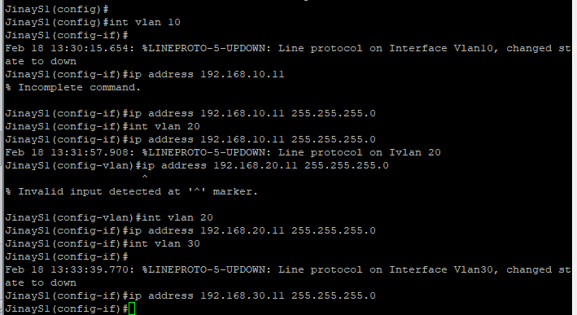

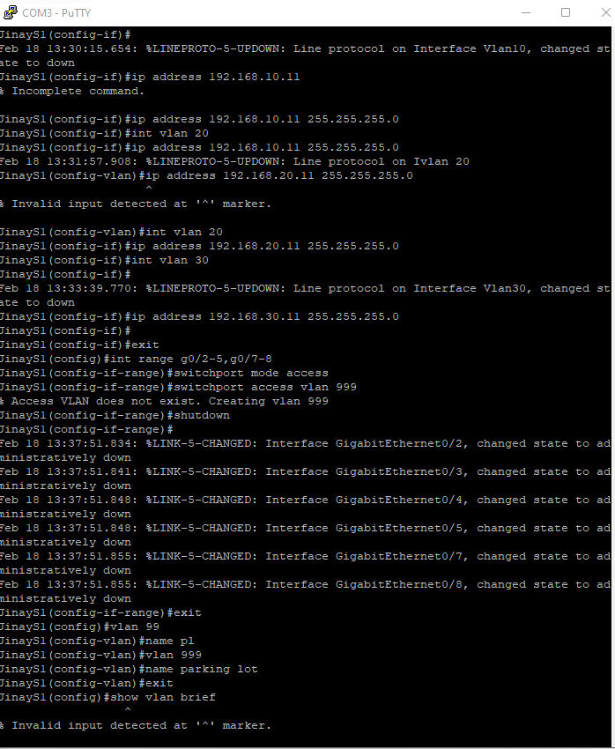

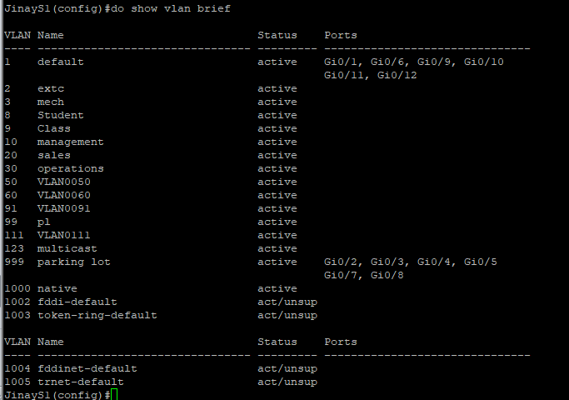

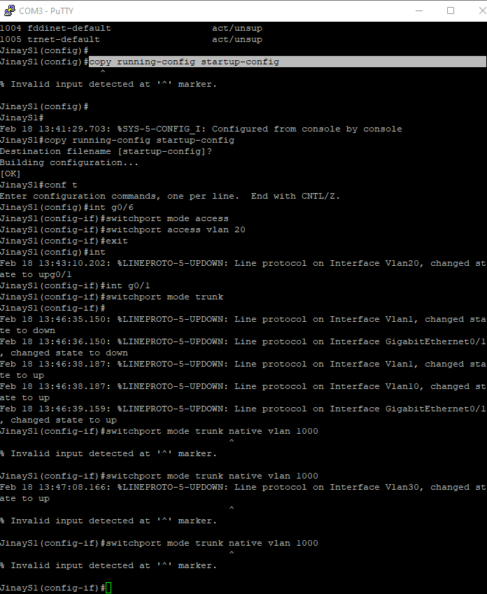

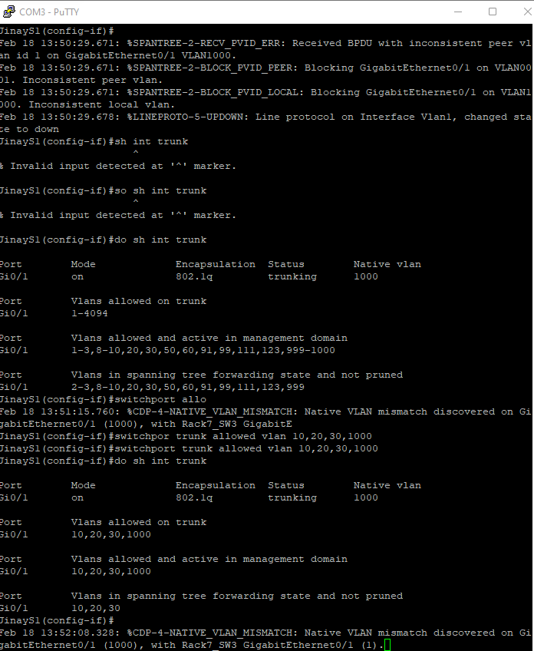

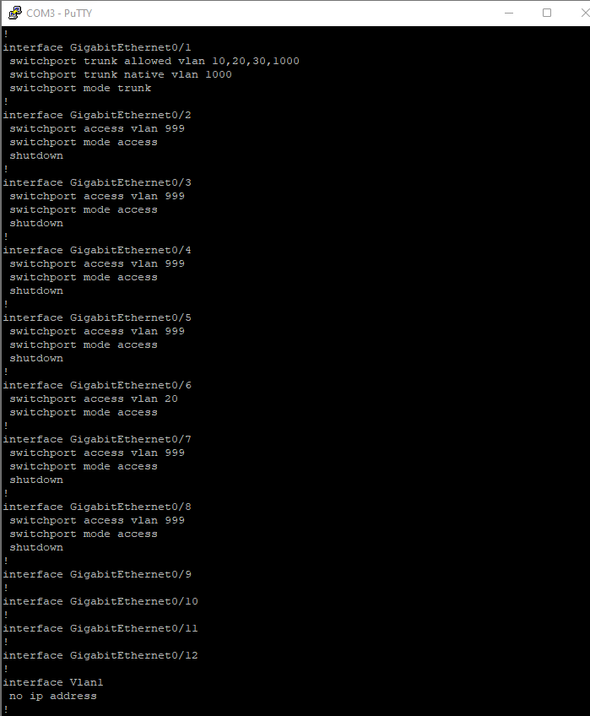

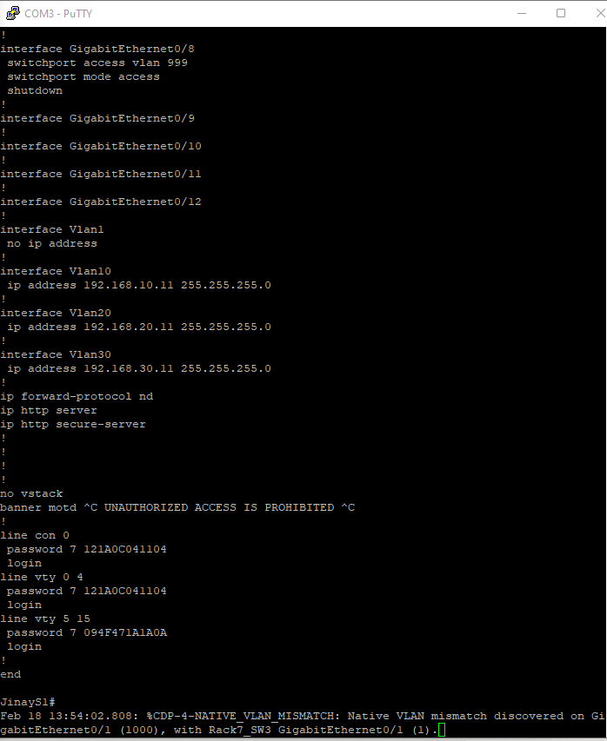

S2

